Unity – Change/Reset Voicemail Password/Pin
- Log in to Unity, click on Users > type in name > click on user

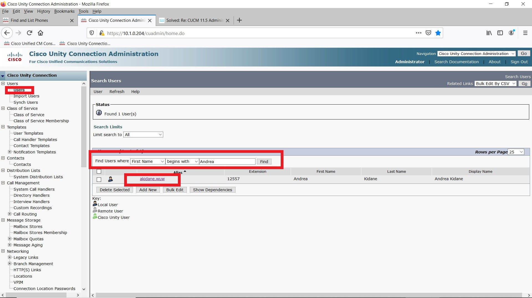

- Hover over Edit

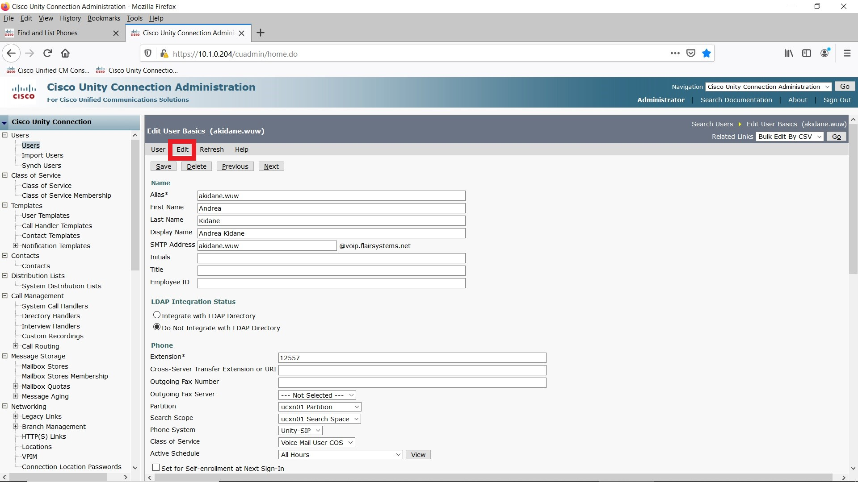

- Scroll to Change Password
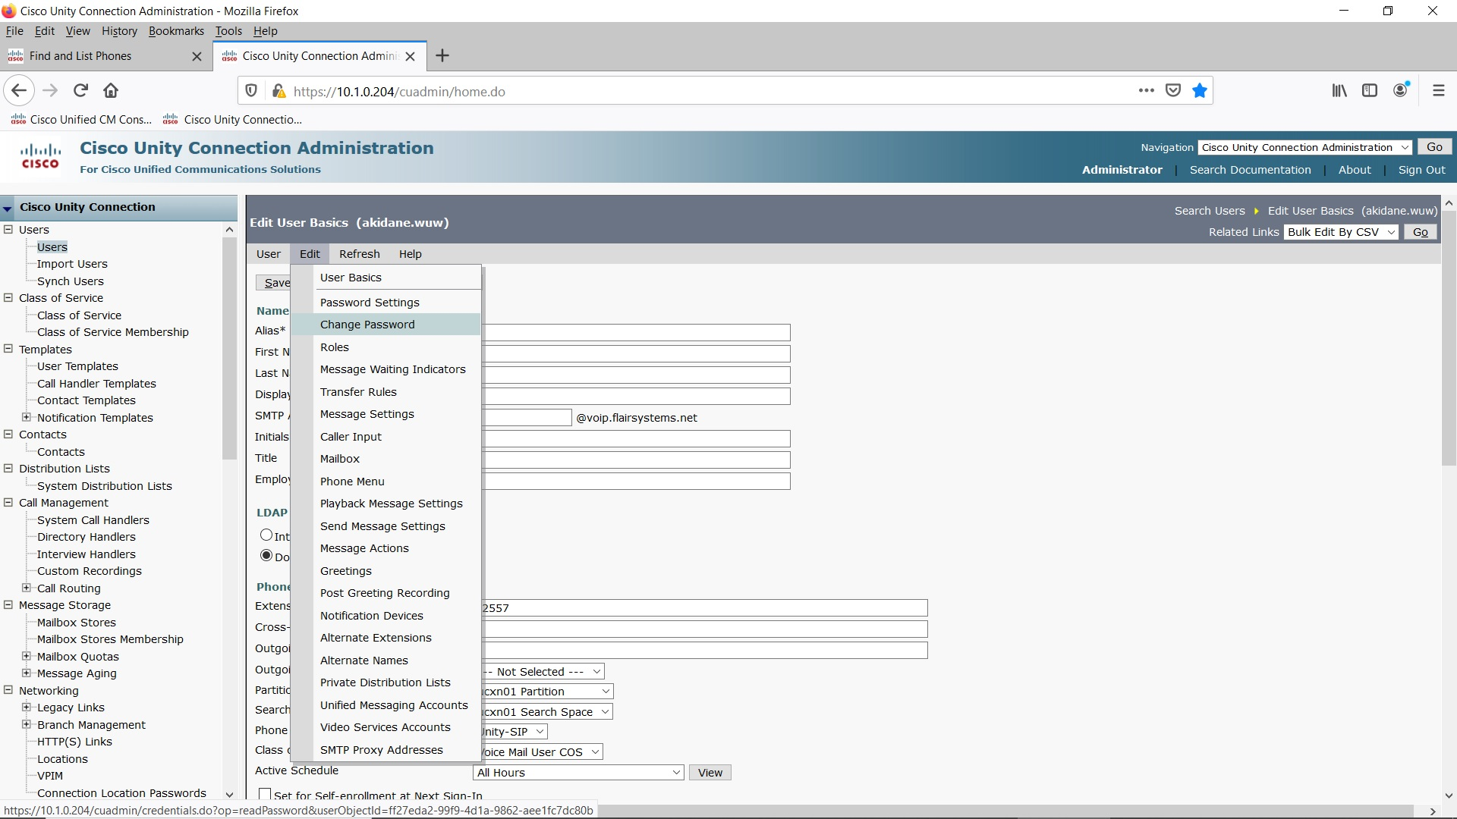

- Under Choose PIN make sure it is Voicemail > type in new PIN x2 > click Save. Done

