Unity – Update Voice Mail

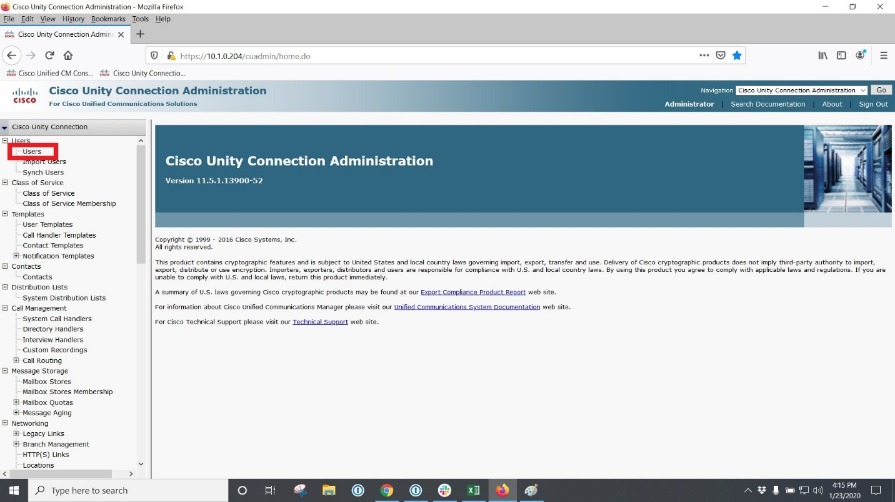
- Log into Unity; on left side panel click on Users

- Find Users Where chose extension and chose begins with then type in extension number
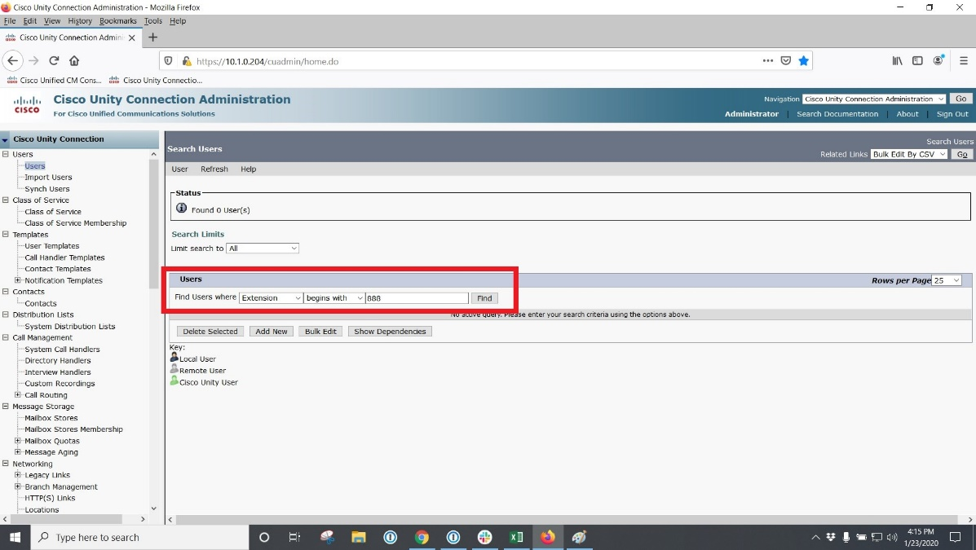
- Click extension to see/edit

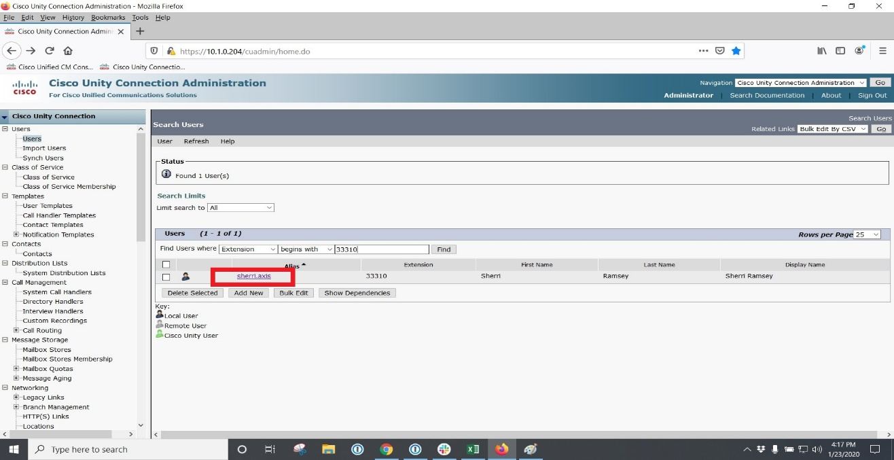
- Hover over edit and found Message actions

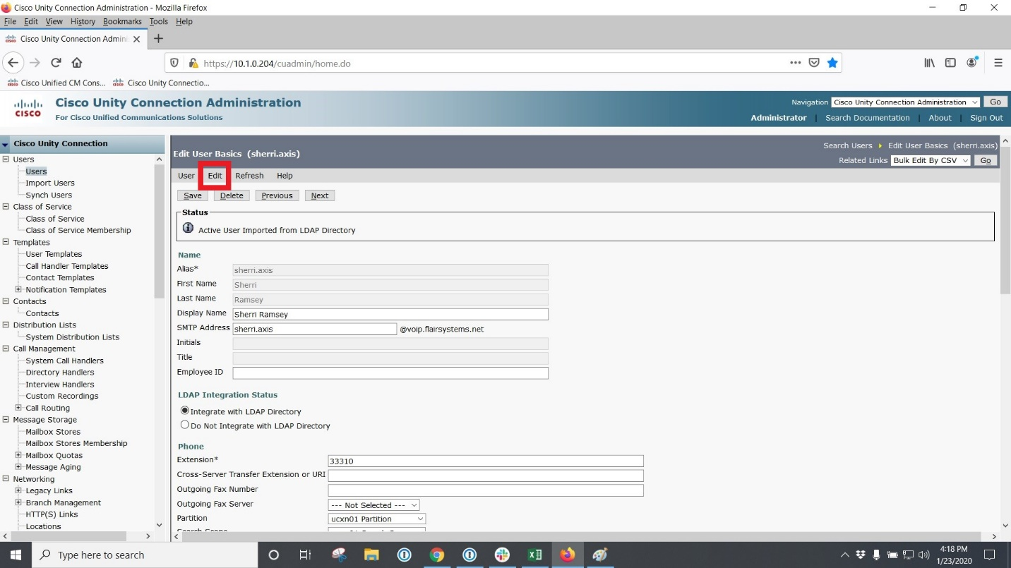

- Message actions
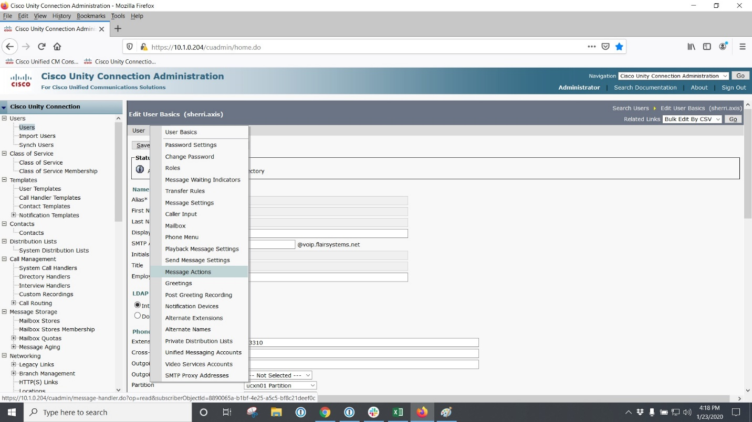

- Fill in box as shown in picture. (note these will vary based on client’s requirements) then click save
